**WORKSHOP: SUPERLATIVE ADJECTIVES**

1. **Look at the following image and watch the next video called: Superlative Adjectives.**

<https://www.youtube.com/watch?v=JoXpuOJkHkg>

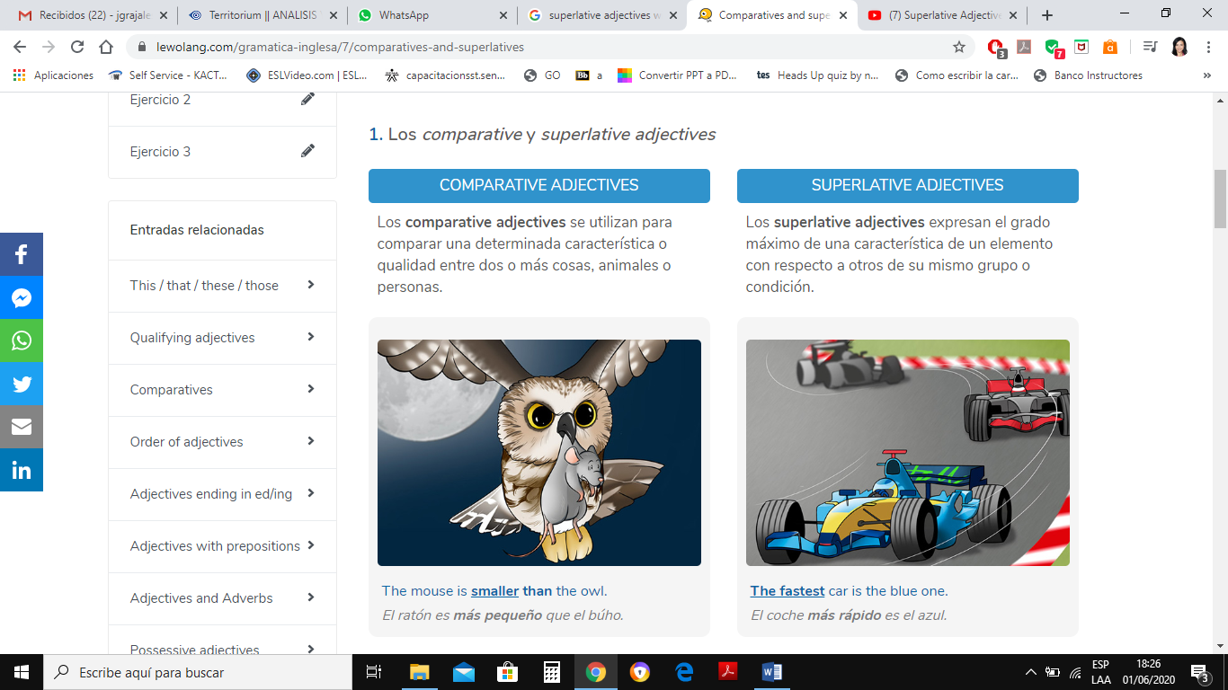

1. **Read the explanation of the Use and Structure of Superlative Adjectives, please take notes.**

**SUPERLATIVE ADJECTIVES**

It is used to stand out a quality of a noun from the same group.

Examples:

Colpatria is **the tallest** building in Colombia.

The Cheetah is **the fastest** animal.

George Clooney is **the most handsome** actor.

Jupiter is **the biggest planet** in our solar system.

Japanese is **the most difficult** language.

**Short Adjectives Long Adjectives**

one or two syllables two or more syllables

Examples: short – The shortest Examples: interesting- the most interesting

tall – The tallest expensive- the most expensive

hot – The hottest boring - the most boring

easy – The easiest handsome- the most handsome

**SPELLING RULES FOR SHORT ADJECTIVES:**

1. If the adjective has one or two syllables, add **est**.

long –**the** long**est** hard- **the** hard**est** slow – **the** slow**est**

1. If the adjective finishes in e, only add st.

wide –**the** wide**st** large- **the** large**st**  nice- **the** nice**st**

1. If the adjective finishes in consonant + vowel + consonant; double the last consonant and add **est.**

big – **the** big**gest** thin- **the** thin**nest** fat –**the** fat**test**

1. If the adjective has two syllables and finishes in Y; it is considered a short adjective so we must change y for **i** and add **est.**

pretty –**the** prett**iest** happy –**the** happ**iest** easy –**the** eas**iest**

**SPELLING RULES FOR LONG ADJECTIVES:**

1. If the adjective has two or more syllables, it is considered a long adjective so we must use the words **the most**.

dangerous – **the most** dangerous beautiful –**the most** beautiful difficult – **the most** difficult

1. If the adjective has two syllables and it doesn’t finish in Y, it is considered a long adjective so we add **the most.**

modern– **the most** modern honest- **the most** honest famous – **the most** famous

|  |  |
| --- | --- |
| **IRREGULAR ADJECTIVES** | |
| Good | The best |
| Bad | The worst |
| Far | The farthest / The furthest |

There are some adjectives that are called irregular as we don´t apply to them the spelling rules explained before. These adjectives have their own form.

**III. Listen to the following audio called: Dictation Superlative and write the sentences as you hear them.**

1. She makes the best lasagna.

2. January is the coldest month of the year.

3. That’s the most expensive hotel in the city

4. Jacob has the messiest apartment I’ve ever seen.

5. What´s the worst day of the week for traveling?

6. Everyone says that´s the most dangerous highway to drive on at night.

7. The easiest way to get to Chicago is by train.

8. He´s the biggest liar.

9. What's the funniest movie you´ve ever seen?

10. Who makes the most money in your household?

**IV. Play the Power Point Presentation called: Superlatives Fun Activity.**

**Online game**

**https://www.eslgamesplus.com/past-simple-irregular-verbs-esl-grammar-interactive-activity-online/**